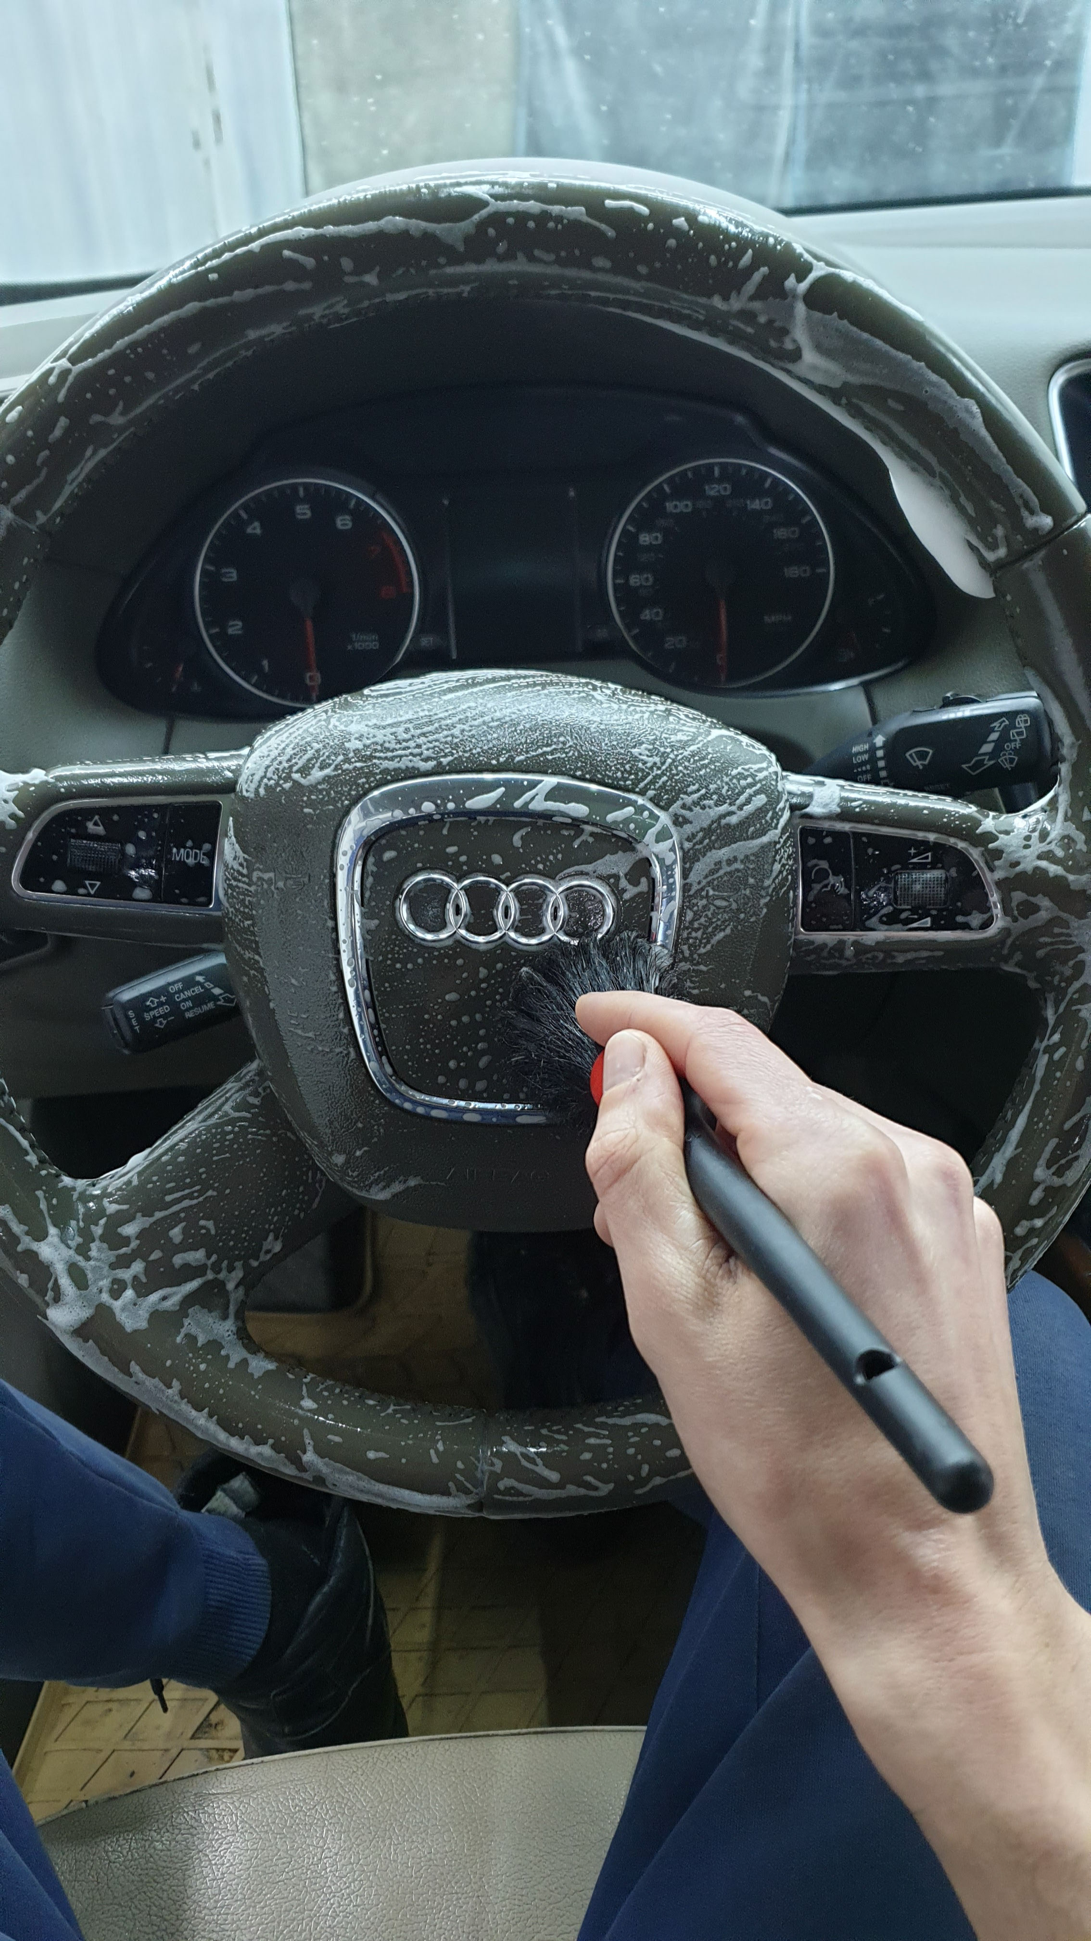[PROPERTY NAME]

|  |  |
| --- | --- |
|  | |
| |  | | --- | | [EVENTNAME] | | [SUBHEADING] | | [If you’re ready to write, just select a line of text and start typing to replace it with your own. View the header to update website, contact details and images.] |  |  | | --- | | [Date]  [Begin time]/[End time]  [Address] | | |  |  | | --- | --- | |  |  | |